2014/15 EACCL Season

**March 11th - Catton Park, Norwich - race 10**

The weather gods shone again. It was a fabulous sunny day for the final race of the season. Thanks to everyone for turning out and I hope you enjoyed the new venue. It was a slighty shorter course than usual so that we could process the final results in a timely manor. Thanks to Bobbie and Chris for this. Bobbie has been fantastic in making the league such a success, I couldn't organise it all without her and Chris who we rope in to everything. They have a solution to everything.

So the new route 2 miles for the ladies and 4 for then men. Based loosely around the park run. We ran an inner loop through the rough ground winding around all the beautiful trees and then to a big loop which was roughly the big loop of the park run until you got to the woody area. We then lead you around the perimeter of the park through the woodland area and popped out back at the start of the first inner loop. It had a bit of everything (except a ditch).

Thank you all for your support throughout the season and I hope we will see you next season for some more muddy fun.

Now I may drag on a bit. I would like to thank all the team captains for planning and organising the races through the season. A massive thanks again to Bobbie and Chris. For today's event I like to thank Wendy Smith, Lynda and Brian Moore, Katherine Trehayne, my mum, Julie London, Mimi Walters, Jeremy and his little boy and Charlie Wood for helping us make the last race possible and also to Nick and the other magic helper who collected all the arrows at the end. Oh and before I close thanks Fergus Anderson for all the fabulous photos this season. I'll set a photo box up for next season so we can link them all there for everyone.

[Click to to view results](https://eaccl.webs.com/Results/15.03.11-EACCL%202014%20Race%2010.xls)

[Races 1-10](https://eaccl.webs.com/Results/15.03.11-EACCL%202014%20Race%2010.xls)

**March 4th - Nowton Park, Bury St Edmunds - race 9**

So here it starts to get interesting for those who have completed all the races as you can drop your slowest results as only the best 8 count towards the final results, for individuals. All rounds count for team results.

The daffodils are so close to being ready to bloom. The mud had dried in the wind since the Suffolk league on Sunday. What a fantastic setting. After all these years there seemed to be more inclines than I remembered. With a change to the normal route I was totally disorientated after a mile or so and was convinced the course would be longer, but no a welcome site was the the good old pitches and bomb hole in the woods. Two laps for the men and one for the ladies. I loved the new route, thanks to the Pacers. Eloise I liked your deviation to "put the tapes back in place" ha ha. Bury St Edmunds must have the record on how many choices of dougnut you can buy.

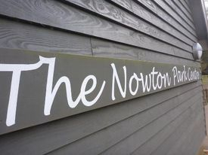

**February 25th - Bacton Woods - race 8**

What another glorious day. Thanks to Bobbie, Chris, Wendy, Brian, Pete and mum for all of your help setting it all up and making it happen. I hope you enjoyed the course. We haven't used this venue for about 8 years.

Its starts with a long straight then hangs to the right through the mountain bike course, before following trails, essentially along the perimeter of the woods. A mixture of terrain with the odd muddy bit and a few hills thrown in for good measure. It then loops back with a nice down hill along side the car park before a splash in the mud and heading up the hill. It twists around before coming back to meet the first lap where the lovely Brian directed us either back to the start with one lap for the ladies. The men went back round for two laps. From Brian its a mad dash back to the finish for a nice cuppa and a biscuit.

My highlight was being Rodney popping out of the bushes to finish as he realised he had missed the final right turn to the finish. Well done everyone. See you next week

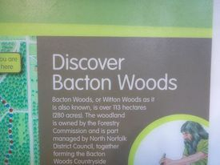

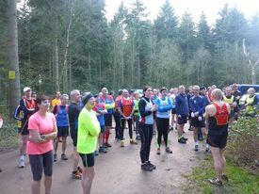

**February 11th - Orwell Park - race 7**

What a beautiful setting. Thanks to Lisa and the Wattisham guys and girls. We ran the course we had two years ago backwards. Down the steep hill winding our way down to the river bank over varied terrain with bridges and mud. Then along the river bank heading slightly in land along farm trails under the Orwell bridge. Very majestic. Then my favourite section along the beach beside the river. We then headed up the hill to the start.Then started again for short loop and back to the finish for the ladies. Then then men should have repeated it all again. So long loop, short loop for ladies then another long loop and short loop for the men.

It did go a little wrong though and the majority of the men ended up doing two big loops followed by one small loop at the end. Hopefully everyone was happy. This is a beautiful route, one of the best in the series. It takes a great deal of time and patience to set up and organise. Hopefully you can all appreciate this and that it is all voluntary and keeps us fit and healthy in the winter months. Its easy to put right the small issues now we know what they are. Hopefully everyone can appreciate the efforts by everyone.Thanks Wattisham it was a fantastic afternoon and a beautiful route.

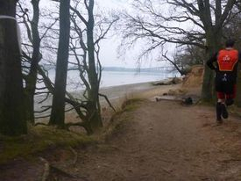

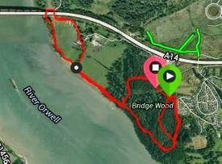

**January 21st - Shouldham Warren - race 6**

It was a cold grey day but the course soon took your mind of that. Thanks to Adam and the RAF Marham guys and girls and for a different route. Nice fast start and after the first right hander we swung left to go along the river. We haven't run down here for several years. Then we wound round woodland and heathland in the Warren. Some nice little hills to keep it interesting too with a fast finish for the ladies. The men had the luxury of another lap. After all the hard work the doughnuts were a welcome end to the run. Thanks everybody.

See you in three weeks at Orwell Park, being hosted by the team from Wattisham.

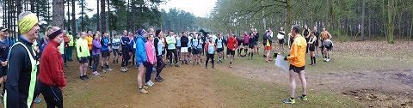

**January 14th - UEA - race 5**

On the first race of 2015 we had a bright cold day. Thanks to Jack and the UEA guys and girls for organising this race. A great mixed bag. Starting on the side on the pitches to a fast start, spreading the field. Heading up the hill and along the track beside Bluebell Road before dropping down the hill to the metal bridge. Once across the bridge the rounded the lake keeping it on our right. Through the gate and up the hill before coming back into the grounds, down the hill seeing the lake again. Through the woods and into Earlham Park. Then the fun bit beside the river in the slippery mud. For the ladies it was then a mad dash to the finish. The men crossed the bridge back beside the river for a shorter 2nd lap. Fabulous, well done to the UEA.

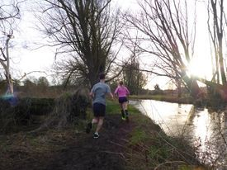

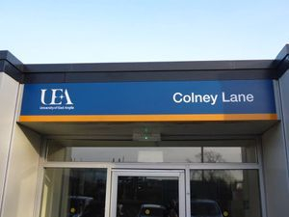

**December 10th - Whitwell Station - race 4**

A beautiful day again for our annual trip to Whitwell and the Reepham Runners. With a fast start out along Marriotts Way and a lovely run along country paths and meadowland. Just as you thought you'd got away with getting wet a lovely little stream crossing before heading back to the station and a rooty lane. Two laps for the ladies and three for the men. Fantastic and as usual a great venue with plenty of drinks and food choices at the end, for the brave even a pint. Thanks Reepham Runners

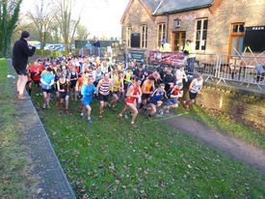

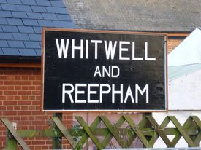

**November 26th - Whitlingham Country Park - race 3**

Thank you to Tri-Anglia for race 3, especially Mark Philo for his usual organisation of a great event and a special thanks to the marshals who were mainly autistic spectrum students from City College. They were very attentive and supportive on such a grey day, lets hope they enjoyed it as much as we did and can come to another local event.

2 laps for the ladies and 3 for the men. To give us a taster of what was to come we had the delights of starting in a waterlogged field, very apt. It was a grey dreary day and I should think when the results come through it was the biggest field of participants in some time. Well done everyone.

Starting in the grassy, undulating, mole hole filled field we charged off and then meandered into the woodland paths before the tough steps to climb up to the highest part of the course before a steep downhill into the playground and across the car park. We crossed the road onto the path before running alongside the lake. Crossing the road to start the next lap along the field. A fast course with the exception of the hard woodland climb.

All finished off with a Jaffa Cake what more could you ask on a drizzly, grey, November day?

See you all in two weeks at Whitwell Station, on December 10th. Hosted by Reepham Runners. Bring some dry shoes and clothes to this one its normally wet and muddy. Can't beat a bit of mud. Lovely

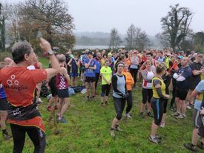

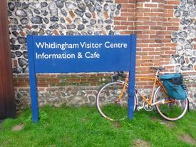

**Race 3 results queries**  
Bobbie has not gone as far as doing the team and individual points yet because there are a few errors here.  
Would you mind looking at these, Wattisham especially for any corrections.  
Wattisham results sheet was a bit of a problematic. It had the same names on both the mens and ladies lists and most people were corporal etc etc. Some of the men finished suspiciously high up the list which makes us think they might have been ladies. We also have two missing numbers 49 and 53. The tags aren't in the box and the numbers aren't written down on any results sheet. If we don't hear of any corrections I will do the individuals and teams on the results with the next race results and highlight any potential errors

**November 5th - Caldeocott Hall Race 2**

Thanks to Andy Baker and the GYRR for hosting race 2. The rains gods were on our side with heavy rain to and from the event just to top the puddles up. It was a tough route, a bit shorter than usual due to the devastation of the woodland but this meant it was a bit tougher as we had a bit more hill as the girls did 2 laps and the men three. A great mixture of terrain.

A great introduction to a nice muddy season. Great turnout again. Thanks everyone.

See you in three weeks at Whitlingham Country Park on November 26th. Hosted by Tri-Anglia.

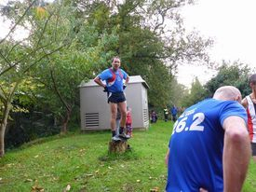

[Photos](https://eaccl.webs.com/apps/photos/album?albumid=15774676)

[Race 2](https://eaccl.webs.com/apps/photos/album?albumid=15774676)

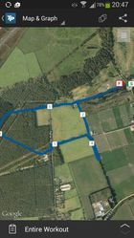

**October 22nd - Honington Race 1 at Knettishall Heath**

A new season begins on such a beautiful day at a new location. Team Honington hosted their race at Knettishall Heath, thanks Ritchie and the team. We had a fabulous turnout with 125 finishers. Thanks to everyone long may it continue. Suffolk Wildlife kindly gave us permission, and in return we kindly supported them with a donation.  One last thanks to Mark Philo who hosted the dedication of our first race to Daryl Davis. Daryl competed in the league for Tri-Anglia and sadly died at this years Round Norfolk Relay. This was marked with a celebratory round of applause and Daryl's wife Kerry competing too.

The route was a great mixture of healthland, woodland and meadows with a bit of mud a few rooty areas and three kissing gates to break your stride which made to the fun. 2 laps for the ladies and 3 for the men.

See you in two weeks at Caldecot Hall

[Photos - Race 1](http://s1348.photobucket.com/user/Madrunner/library/EACCL%2014_15%20Race%201%20-%20Knettishall%20Heath?sort=3&page=1)

